DASH Azure Databricks

Important Note
Users who need Azure Databricks access must contact the DASH Team.
- The DASH Team will add the user to the Azure Tenant, enabling them to create Databricks workspaces within the DASH environment.
- Additionally, the user’s email address must be added to the DASH allow list.
- Only after being allow-listed will the user be able to create and manage Databricks resources via the DASH Portal.

Input Guide
This outlines the input parameters available during Azure Databricks provisioning via the DASH Portal. Each row describes a specific parameter, including its meaning, possible values, recommended values, and any valid combinations.
Input Parameter | Description | Values Provided | Value Guidance | Valid Combinations
Requestor Name | Name of the person requesting Databricks deployment. | e.g., John Doe | Used for tracking and approvals. | N/A
Email | Email address of the requester. | e.g., john.doe@example.com | Must be valid; used for notifications & user creation. | Must match Azure AD identity if SSO is enabled.
Databricks Workspace Name | Name of the Azure Databricks workspace. | e.g., Databricks | Must be unique in the chosen region. | N/A
Region | Azure region where the workspace will be deployed. | East US, Central US, West US 2, Central India, UK South, Canada Central, East Asia, South Central US | Choose the one closest to your workload for better latency. | N/A
Pricing Tier | Determines the features/performance of Databricks. | Standard, Premium | Premium recommended for RBAC & enterprise security. | Premium is needed for advanced governance features.
Storage Account Tier for External Location | Performance tier for linked external storage. | Standard, Premium | Standard for general use; Premium for high-performance workloads. | Premium requires BlockBlobStorage/FileStorage.
Storage Account Redundancy for External Location | Data replication type for external storage. | LRS, ZRS, GRS, RAGRS, GZRS, RAGZRS | LRS for low cost, ZRS/GRS for resiliency. | Premium supports only LRS & ZRS.
Storage Account Kind for External Location | Type of storage account. | StorageV2, BlobStorage, BlockBlobStorage, FileStorage, Storage | StorageV2 is recommended for Data Lake Gen2. | Premium requires BlockBlobStorage/FileStorage.
Container Access Type for External Location | Access level for blob container. | private, blob | private → Recommended for security. No anonymous access.  - blob → Public read access to blob objects only, container listing not allowed.  - container → Full public read access to container and all blobs inside. | N/A
owner | The team or individual responsible for provisioning, managing, and maintaining the resource. | Specify the team name or individual responsible for maintaining the resource. | Provide correct team/individual name. | N/A
project | Project or initiative name linked to the resource. | Indicate the project or initiative name related to the resource. | Provide the project name related to the resource. | N/A
deployment | The target environment (e.g., development, testing, prod) where the resource will be provisioned. | Define the deployment environment name (e.g., dev, test, prod) | Choose the environment where the resource has to be provisioned. | N/A
Services expire after 30 days. Create this service now, or schedule for a later date? | Azure Databricks will be deleted 30 days after creation, or it can be scheduled to be created at a later date. | Create Now (or)  Schedule for Later | Choose based on Azure Databricks requirements. | N/A

Valid Tips:
Storage Type | Tier | LRS | ZRS | GRS | RAGRS | GZRS | RAGZRS
StorageV2 | Standard | ✅ | ✅ | ✅ | ✅ | ✅ | ✅
BlobStorage | Standard | ✅ | ✅ | ✅ | ✅ | ❌ | ❌
BlockBlobStorage | Premium | ✅ | ✅* | ❌ | ❌ | ❌ | ❌
FileStorage | Premium | ✅ | ✅* | ❌ | ❌ | ❌ | ❌
Storage (v1) | Standard | ✅ | ✅ | ✅ | ✅ | ❌ | ❌

Sample Input Selection:
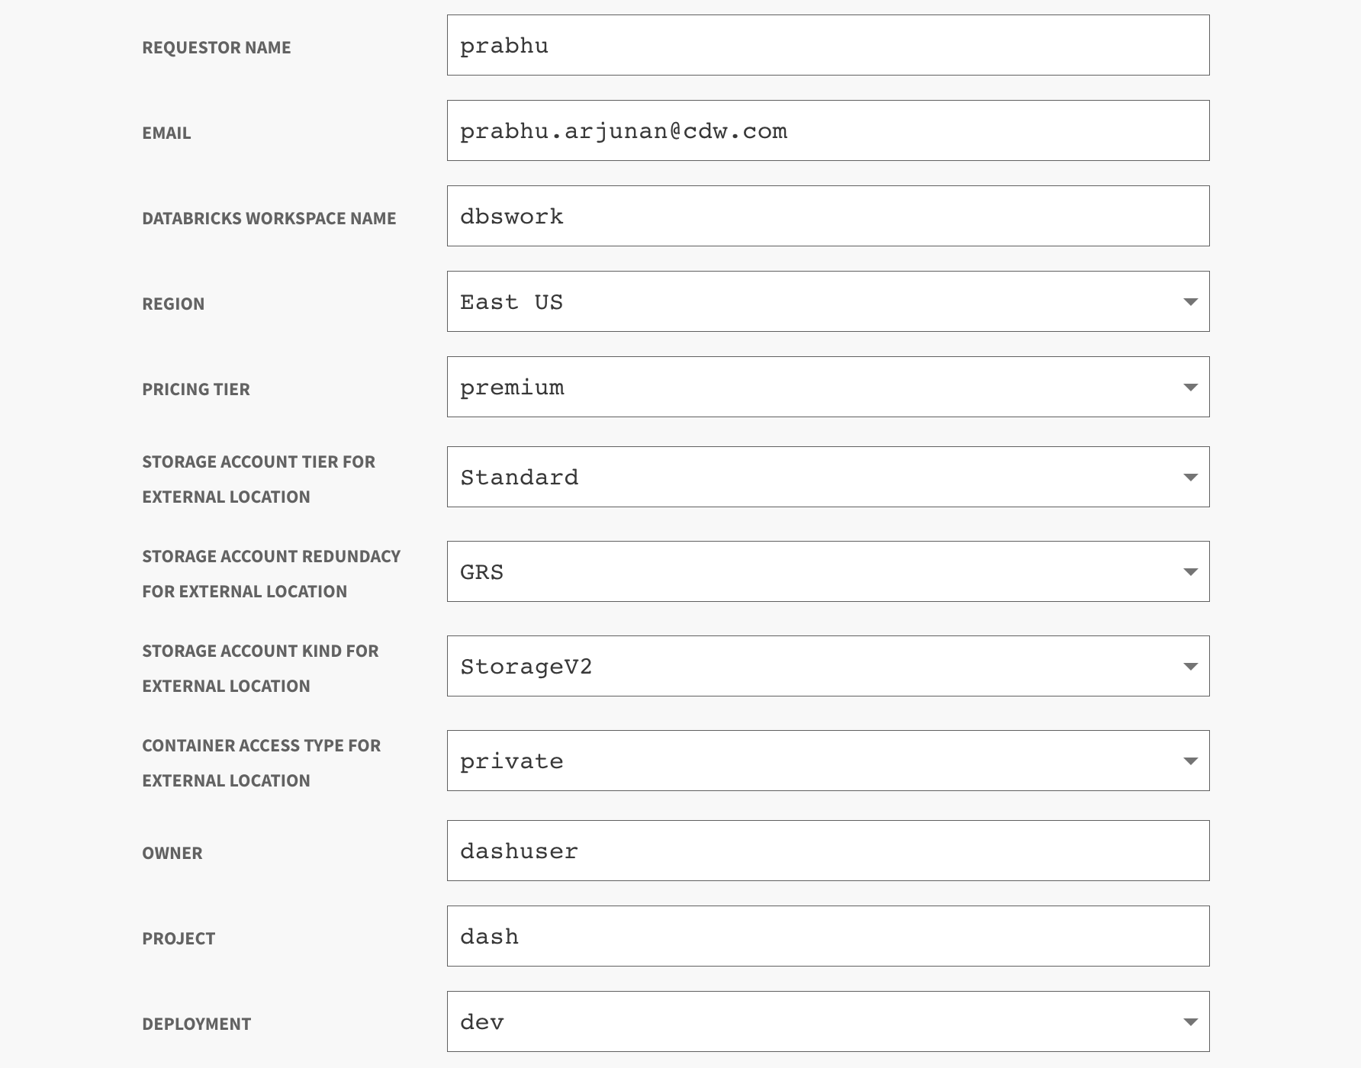
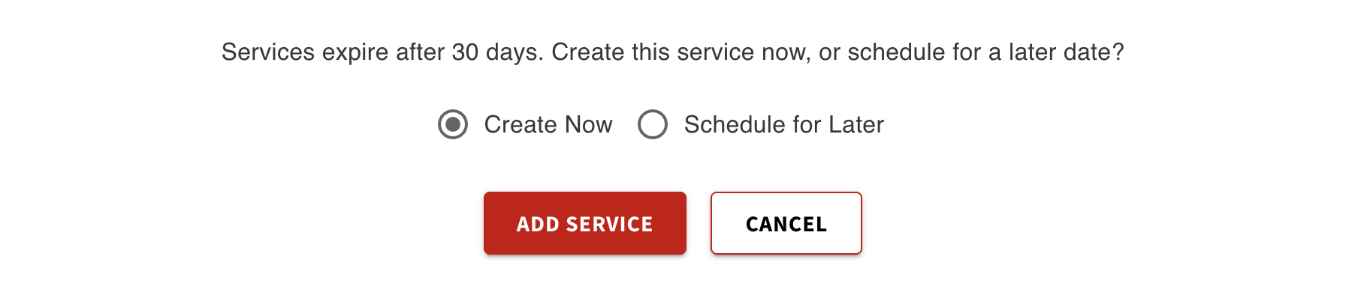

Output Guide

After provisioning the Azure Databricks workspace, the following output values are available.
These outputs are essential for accessing the Databricks web console, identifying the workspace, configuring user authentication, and integrating with external storage.

Output | Description | Example Value
databricks_user_email | Email address of the Databricks user that was created. | john.doe@example.com
workspace_url | URL for accessing the Databricks workspace (format: adb-{workspaceId}.{random}.azuredatabricks.net). | https://adb-1234567890123456.7.azuredatabricks.net
workspace_id | Unique identifier for the Databricks workspace. | 1234567890123456
resource_group_name | Name of the resource group where the workspace is deployed. | dash-databricks-rg
storage_account_name | Name of the storage account used for the external location. | dashstgextloc1
unity_catalog_container_name | Name of the Unity Catalog container in the storage account. | unity-catalog-container
raw_data_container_name | Name of the Raw Data container in the storage account. | raw-data-container

What You Can Do with These Outputs
The outputs provided after provisioning your Azure Databricks workspace through the DASH Portal enable you to securely access and manage your environment via the Databricks Web Console and integrations with external storage.

Access the Databricks Workspace

Open a browser and go to the Workspace URL from the output:
https://adb-<workspaceId>.<random>.azuredatabricks.net
Log in using your Azure AD credentials.
The databricks_user_email from the output must be allow-listed by the DASH Team.

Additional details:
1. Identify Your Workspace
Use the workspace_id from the output for automation scripts or CLI/API interactions.
Example:
databricks configure --host https://adb-<workspaceId>.<random>.azuredatabricks.net

2. Locate Your Resource Group
The resource_group_name output indicates where your Databricks workspace and related Azure resources (e.g., networking, storage) are deployed.
This is useful for Azure CLI commands such as:
az resource list --resource-group <resource_group_name>

3. Access External Storage
The storage_account_name, unity_catalog_container_name, and raw_data_container_name outputs provide the names of the external storage resources connected to your Databricks workspace.
List containers in the external storage account:
az storage container list \
--account-name <storage_account_name> \
--output table

4. Mount Storage in Databricks
Use the output values to mount external containers inside Databricks notebooks:
dbutils.fs.mount(
source = "wasbs://<unity_catalog_container_name>@<storage_account_name>.blob.core.windows.net/",
mount_point = "/mnt/unity-catalog",
extra_configs = {"fs.azure.account.key.<storage_account_name>.blob.core.windows.net": "<storage_account_key>"}
)

This way, the outputs not only let you log in and manage the Databricks workspace, but also securely integrate and access external storage from within Databricks.

